ANNUAL PARISH MEETING
For all residents of Washington, Heath Common, & Milford Grange
2023

Organised by
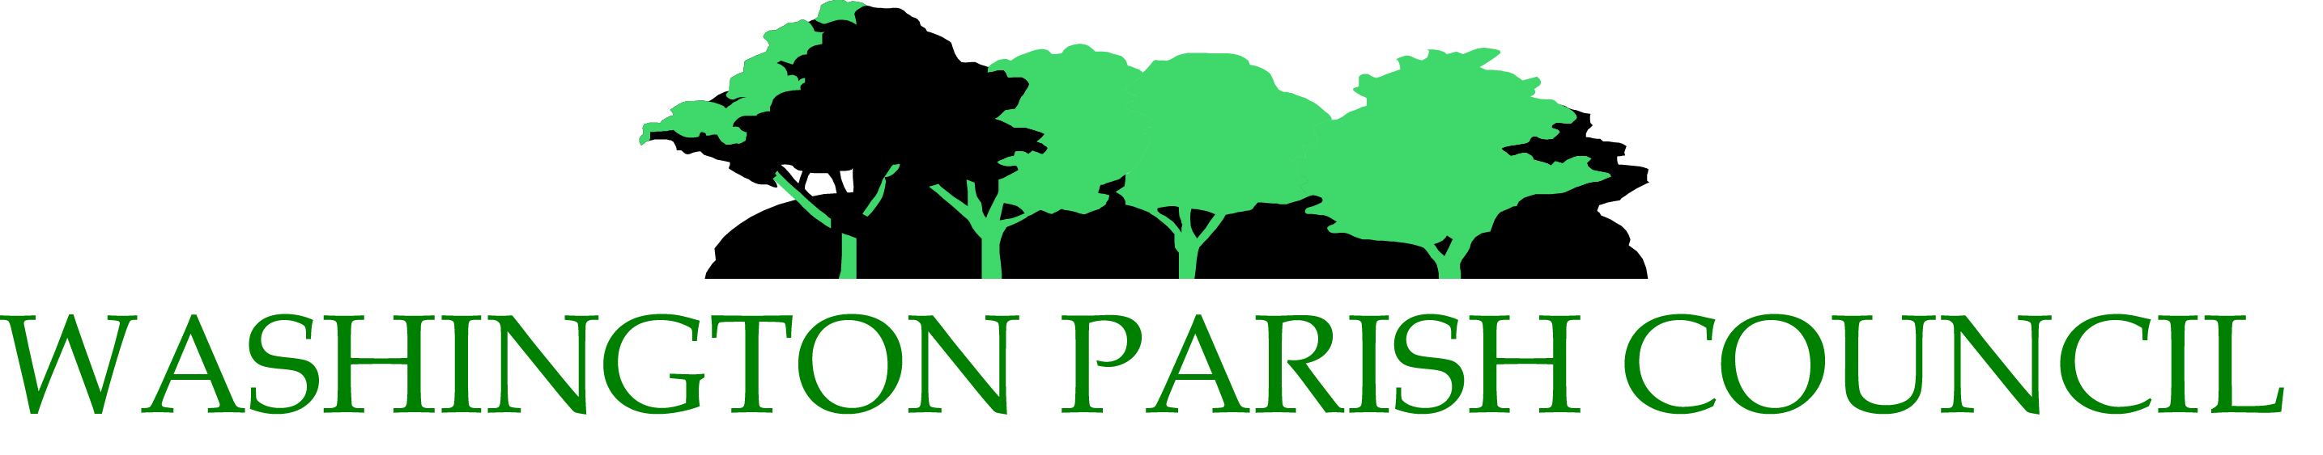

Friday 10th March - 7.30pm at Washington Village Hall
(Chanctonbury Room), School Lane, RH20 4AP

GUEST SPEAKER: ANDREW GRIFFITH MP

VIEW OF THE PAST YEAR AND CURRENT COUNCIL PROJECTS

HAVE YOUR SAY ON MATTERS OF LOCAL CONCERN

HEAR FROM YOUR DISTRICT AND COUNTY COUNCILLORS, SUSSEX POLICE etc

ADMISSION FREE ......HAVE A CHAT WITH YOUR PARISH COUNCILLORS

Enjoy Complimentary Wine, Tea, Coffee, and Snacks!

DON’T MISS THE OPPORTUNITY TO ENGAGE WITH THE PARISH COUNCIL AND BE PART OF WHAT’S HAPPENING IN OUR AREA!

